CPE 400/600: Computer Communication Networks

Instructor: Shamik Sengupta

**HW 2 (Total 20 points)**

**Assigned on: Sep 29, 2020, Due back on: Oct 5, 2020**

**(Submission through WebCampus)**

**Submission format: Microsoft Word or pdf only**

**(file name: HW1_ Odeh_Issa)**

**Part 1**

1. **[2]** Why TCP uses a 3-way connection establishment process rather than simple connection request and response (2-way protocols)? **A 2 -way connection would only allow one party to establish an ISN, and the other party to acknowledge it (only one party can send data).**

2. **[2]** Consider a TCP connection between Host A and Host B. Suppose that one TCP segment traveling from Host A to Host B have the following information:

Source port: x

Destination port: y

Seq no.: 135

Ack no.: 426

Segment length: 126 bytes

What will be the corresponding information (source port, destination port, seq no., and ack no.) for the segment traveling from Host B to Host A? **Source port number y and destination port number x.**

3. **[3+3+4=10]** Assume TCP congestion control based on Reno/Tahoe protocol. Initial ssthreshold = 32.

* 1. First segment loss occurs after 7 transmissions. Loss is indicated by timeout. What will be the current congestion window (CWND) and ssthreshold at the 8th transmission? **CWND will equal 1 mss due to a timeout occurring which creates a new ssthreshold. New ssthrehold will be 33/2 ≈ 16.5 = 16**
  2. After 3 more transmissions (8th, 9th and 10th) at the 10th transmission, segment loss happens. This time, loss is indicated by 3-DUPACKs. What is the current congestion window (CWND) and ssthreshold at the 11th transmission? **ANS below**
  3. After this 2 more transmissions happen (11th and 12th) without any loss and the transmission process is completed. What will be the current congestion window (CWND) and ssthreshold value after the 12th transmission? **ANS below**

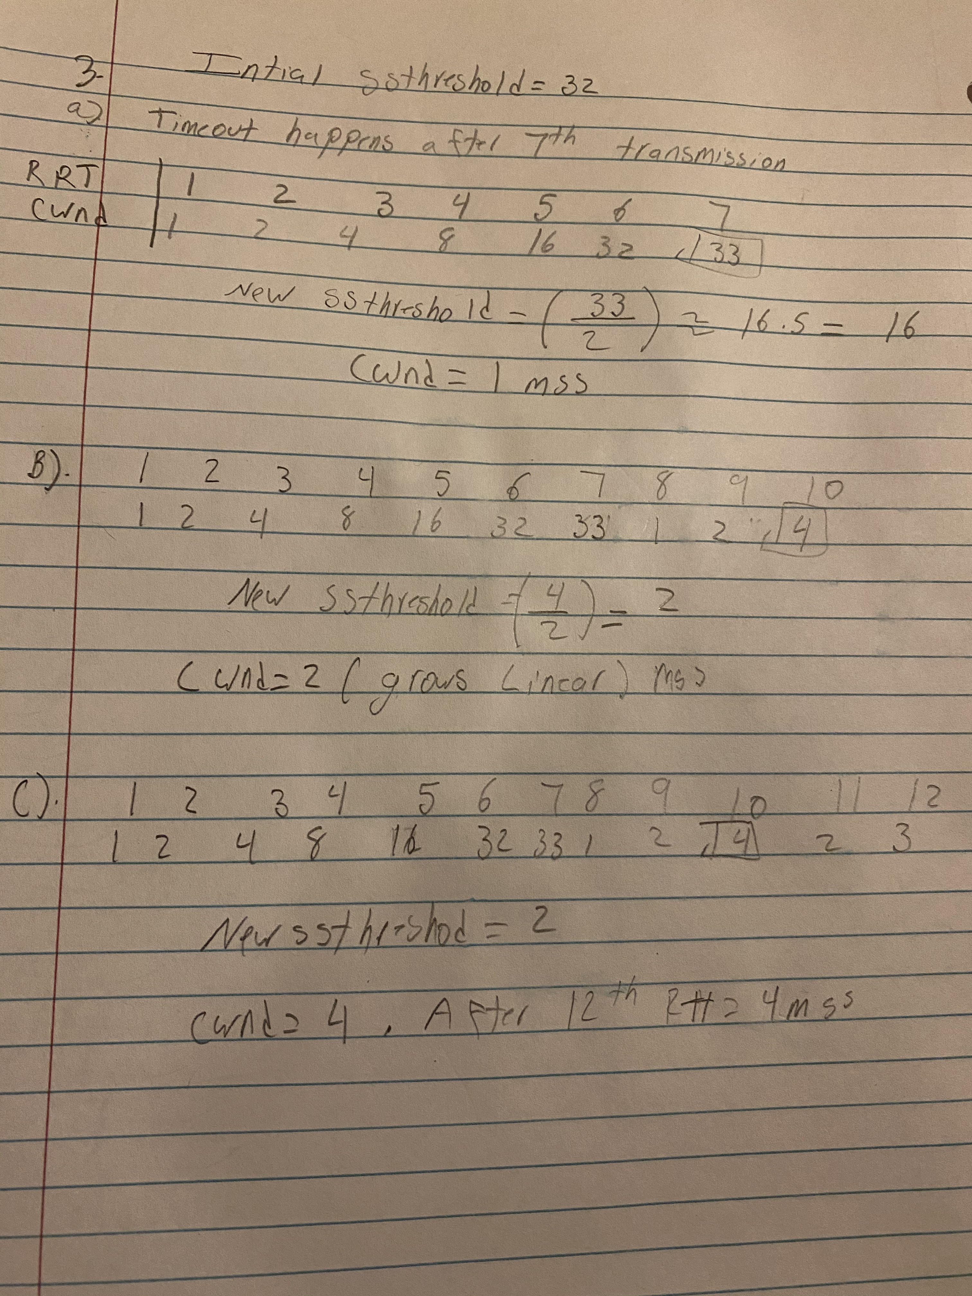

Show your steps through X-Y plot. If you make any explicit assumption, state clearly. Provide clear answers.

**Part 2**

In this part, we’ll explore transport layer through wireshark. We’ll do so by analyzing a trace of the TCP segments sent and received using the given packet capture (HW2-P2.pcapng).

* Open the HW2-P2 packet capture using wireshark.
* Enter “http” (just the letters, not the quotation marks) in the display-filter-specification window, so that only captured HTTP messages will be displayed in the packet-listing window.
* Select the first Get packet and open the transport layer detail of this packet.

**Answer the following questions. When answering the following questions, you should take screen shots and indicate where in the screenshots you’ve found the information that answers the following questions.**

4. **[1]** What is the source port of the client in this message? What is the destination port?

Source Port: 37662, Destination Port: 80.

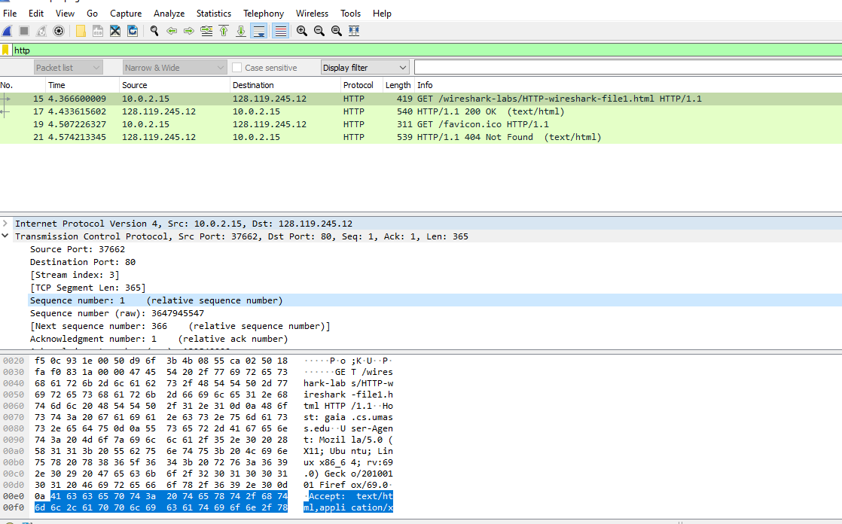

5. **[2]** What is the relative sequence number of this packet that wireshark displays? What is the actual sequence number of this packet? (Hint: To see the actual sequence numbers, go to Preferences>Protocols>TCP and uncheck “relative sequence numbers”.)

**Relative sequence number : 1. Actual Sequence number: 3647945547**

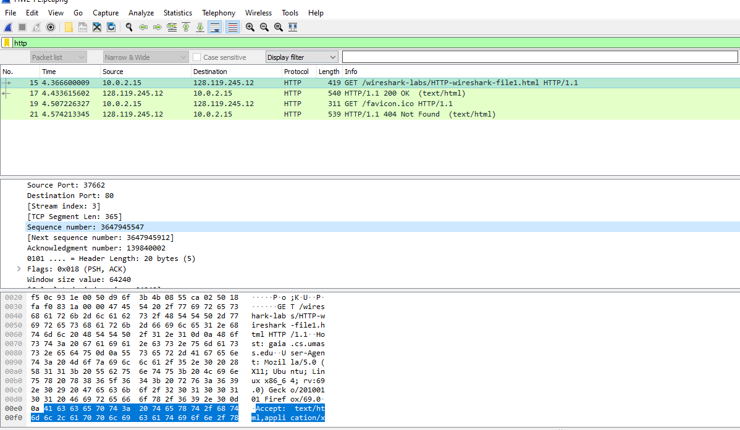

6. **[2]** What are the TCP flag status in this packet? Can you think of some justifications of the flags’ status? **TCP status: 0x018(PHS,ACK). Tcp flags are used within the TCP packet that transfers to indicate a specific connection state to even provide additional information. Therefore, they can be used to trouble shoot purposes to control how a particular connection is handled.**

7. **[1]** Is SYN flag set to 1 in this packet? If yes, why yes? If not, why not? **Yes it is, this means the ACK number field should be examined.**